**Electronics Refurbishment**

**Portfolio**

**Evan Frackelton**

**Mechatronics Engineer**

**Table Of Contents**

1. **Gameboy Advance SP (Zelda Edition) 4**
2. **Gameboy Color (Atomic Purple) 5**
3. **Gameboy Color (Clear)**

**Contextual Vocabulary**

[1] **IPA** – Isopropyl Alcohol; Commonly used to clean motherboards due to its rate of evaporation and non-conductivity.

[2] **ABS Plastic** – Acrylonitrile Butadiene Styrene plastic: Commonly used thermoplastic.

[3] **Retrobrighting** – The process of using Hydrogen Peroxide and UV light to remove the yellowing of ABS plastic that appears with age. It got its name from the root word “Retro” meaning object or design from the past and “-brighting” from the use of UV to catalize the process.

**Gameboy Advance SP (Zelda Edition)**

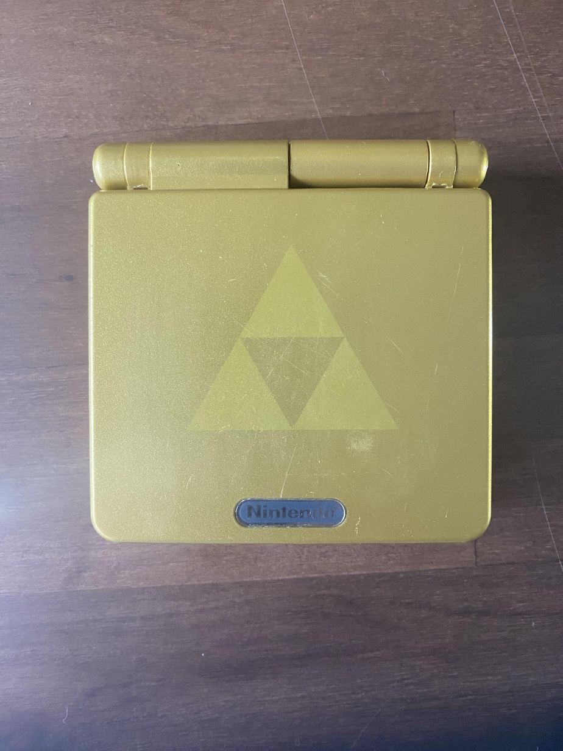

*Figure 1.1: Outside Case*

**Problems:**

* Console turns on but shuts off randomly
* Expanded Lithium Ion Battery
* Dirty motherboard board and components
* Corroded Ports

**Repairs:**

The motherboard was dusty so IPA[1] was used to clean it as well as the ports and components. The power switch was dirty which was causing the console to randomly shut off. Taking out the switch, cleaning it, and resoldering it fixed that issue. The battery was also replaced because the original was slightly bloated. The ports are corroded but it does not seem to be affecting the continuity. The case was also fully cleaned with IPA as well as the inside of the case below the motherboard, including the buttons and speaker.

**Gameboy Color (Clear Purple)**

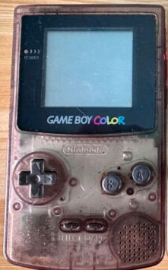

*Figure 2.1: Gameboy color as purchased*

**Problems:**

* Does not Power on
* No polarizer on screen
* Ribbon Port that connects screen has bent corroded pins
* Corroded battery terminals
* Dirty motherboard
* Dirty casing
* Speaker does not work

**Repairs:**

The motherboard was dirty and the battery terminals were corroded so the first thing that I did was clean them to try and fix the problem with the console not powering on. The casing of the console was dirty and yellowed. Using IPA, the dust was cleaned but the yellowing of the plastic will require some more work. Yellowing occurs in ABS plastics[2] when polymer chains degrade from UV radiation and is common with old plastic electronics like our specimen in Figure 2.1. Due to the purple color the yellowing is hard to notice, but it is present.

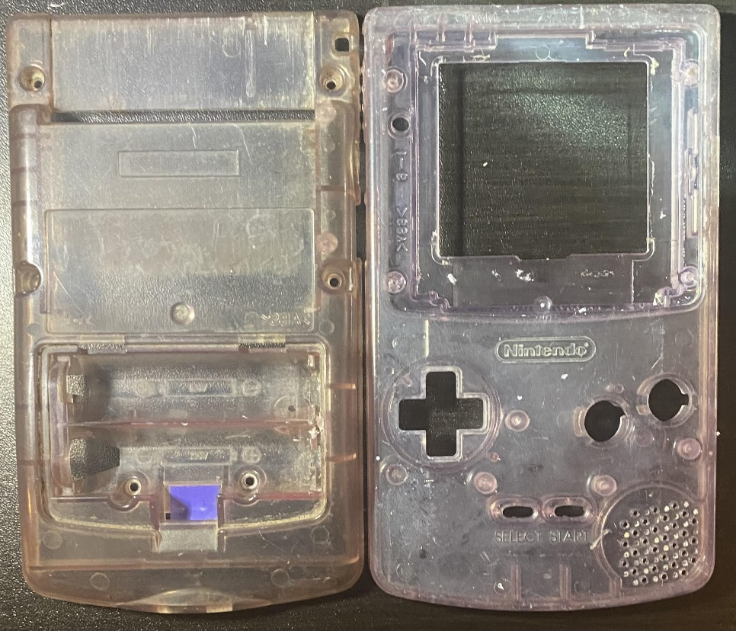

*Figure 2.2: Yellow reversed case comparison*

When polymer chains degrade from UV radiation, stabilizing agents in the plastic form free radicals. Hydrogen peroxide (H­202) binds to the free radicals and reverse the yellowing in the plastic. By submerging the plastic casing in hydrogen peroxide and putting UV light under it, the bonding begins and over the next few hours the yellowing is removed. Figure 2.2 shows a clear difference between the yellowed and non-yellowed plastic. For clarification, the front panel on the right is the one that was what the restoration community calls, “Retrobrighted[3]” or “de-yellowed”.